Agri Seed Center form Design and Coding


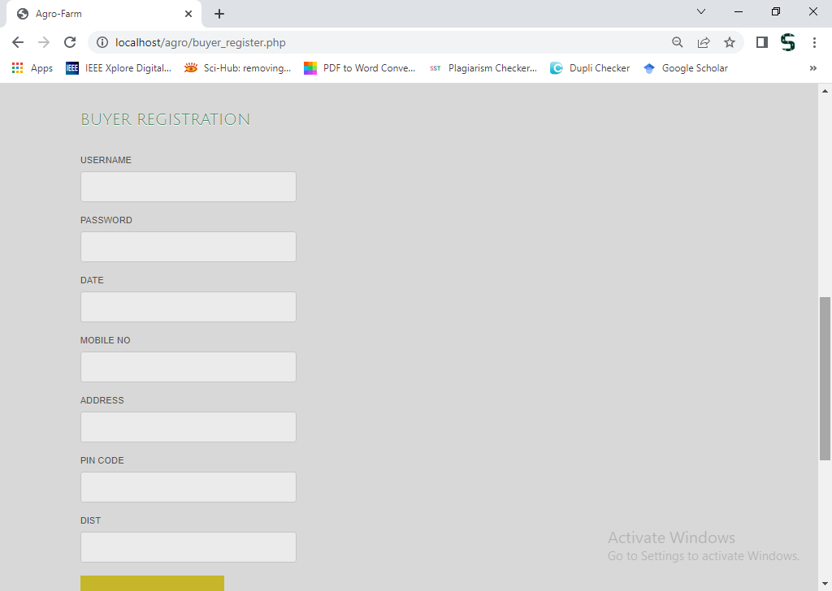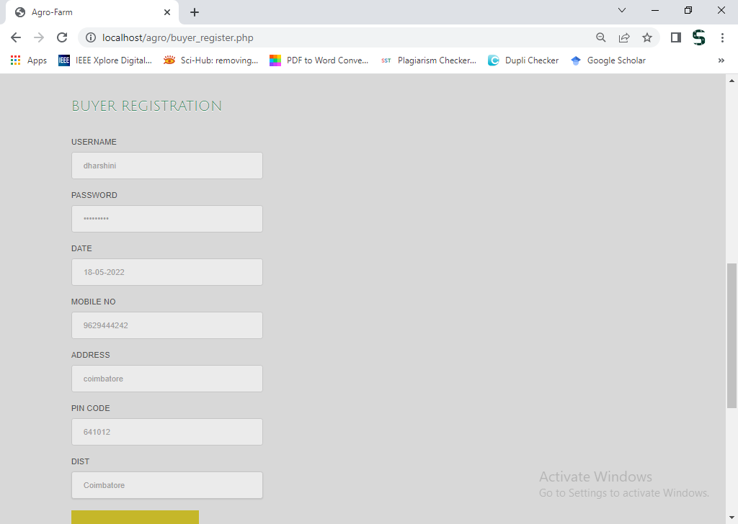

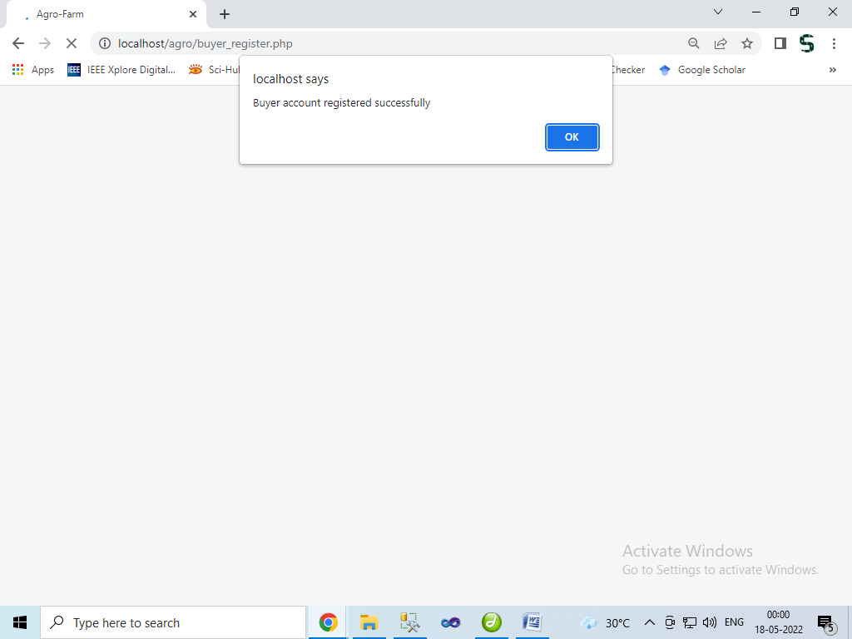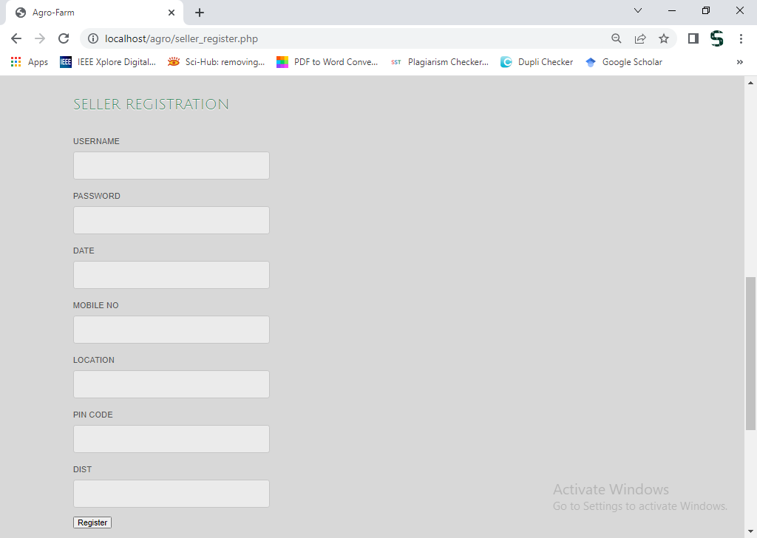

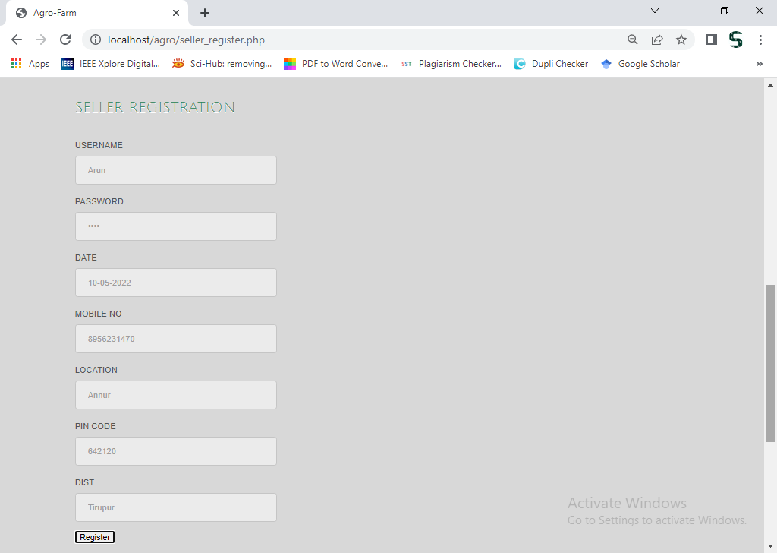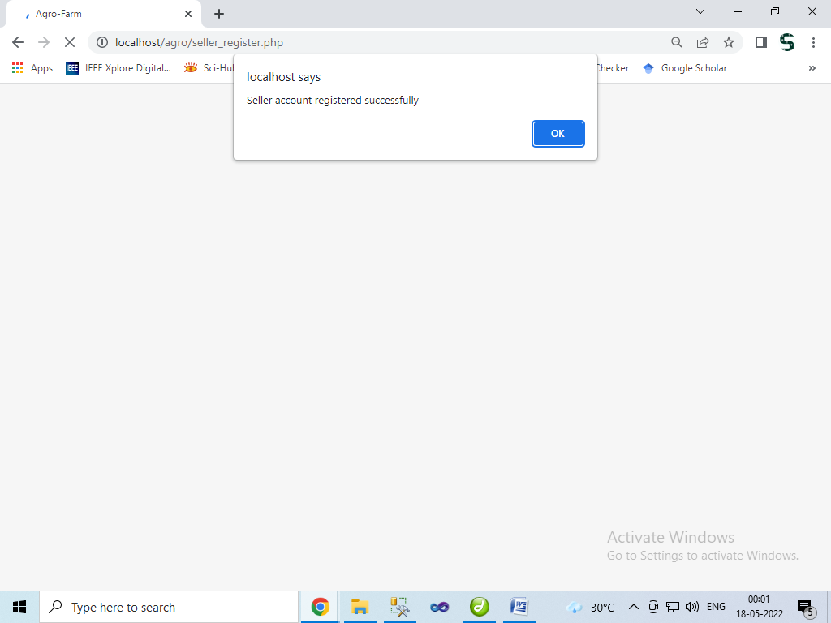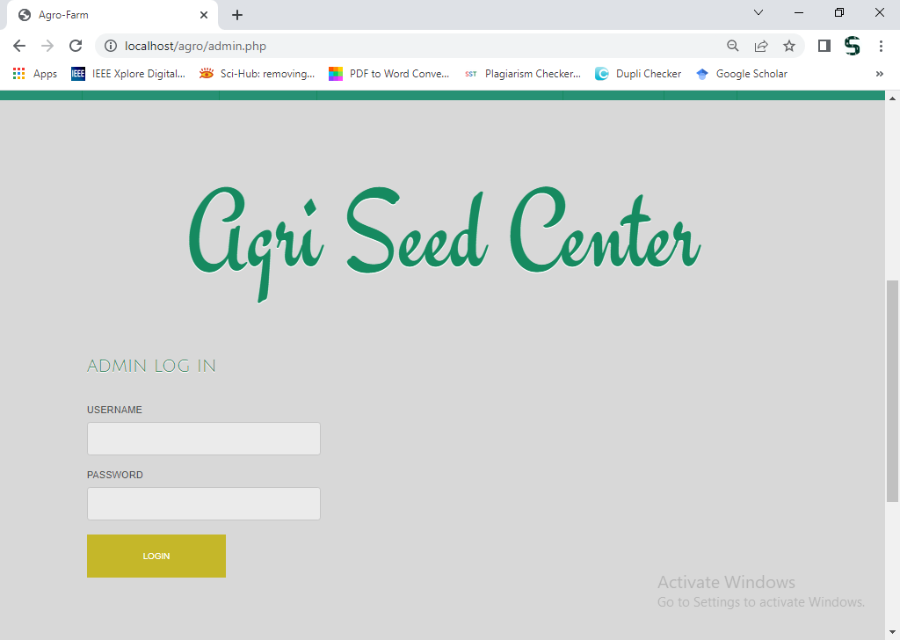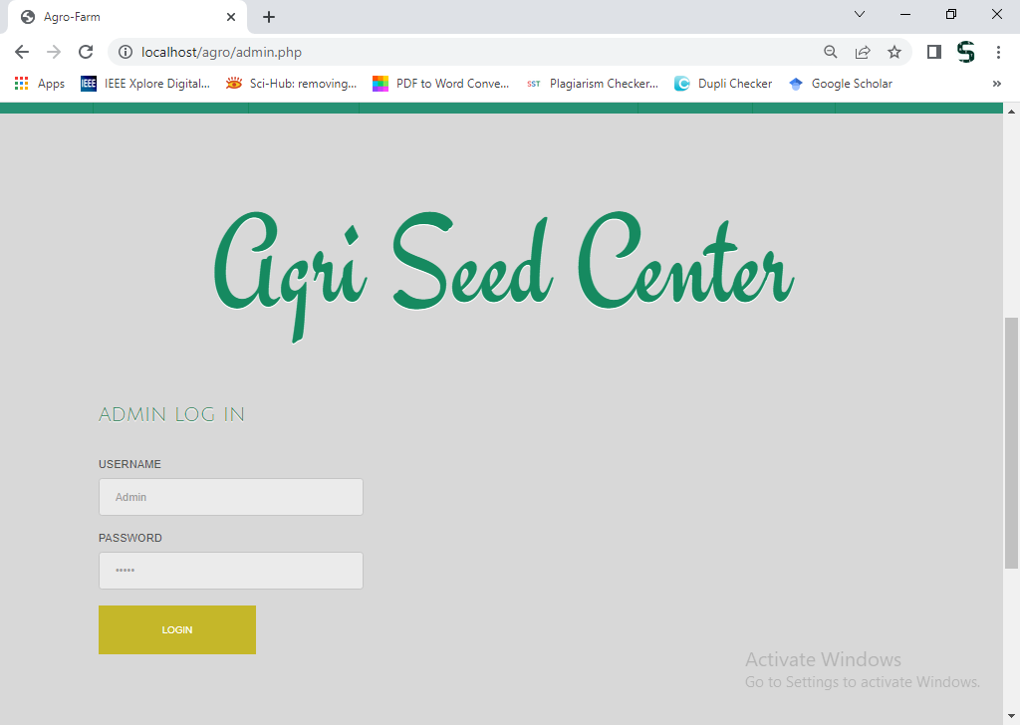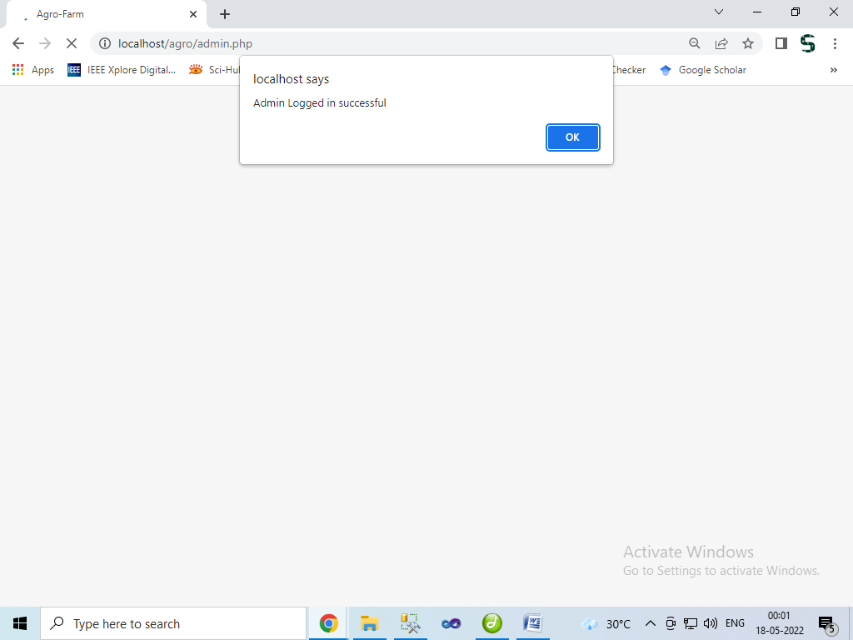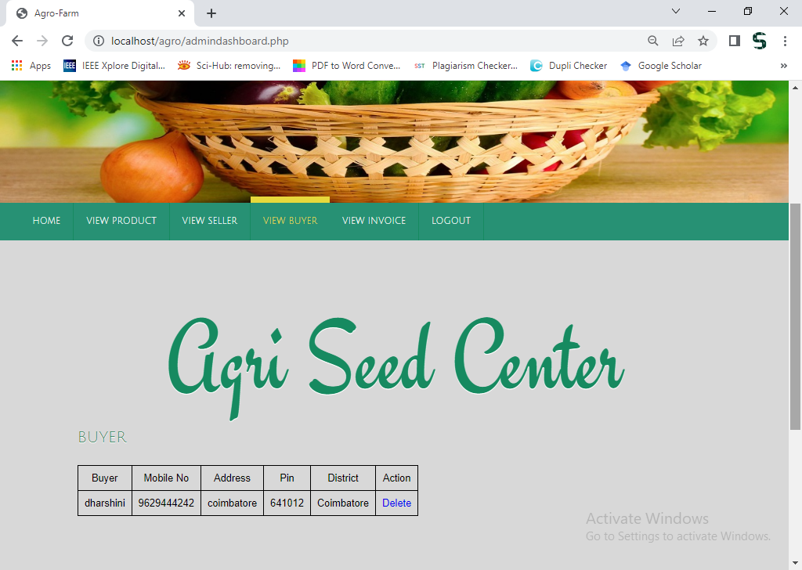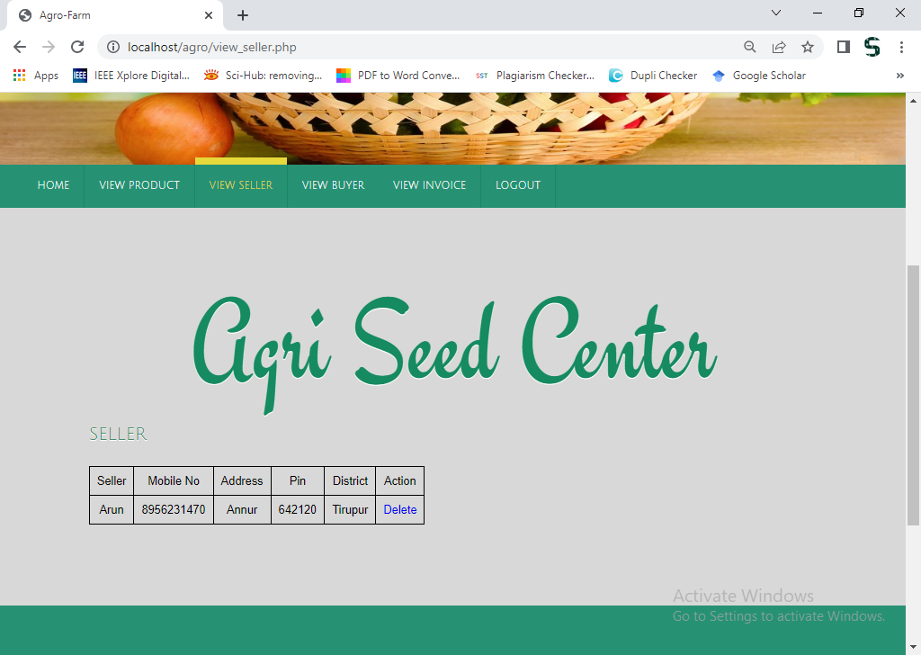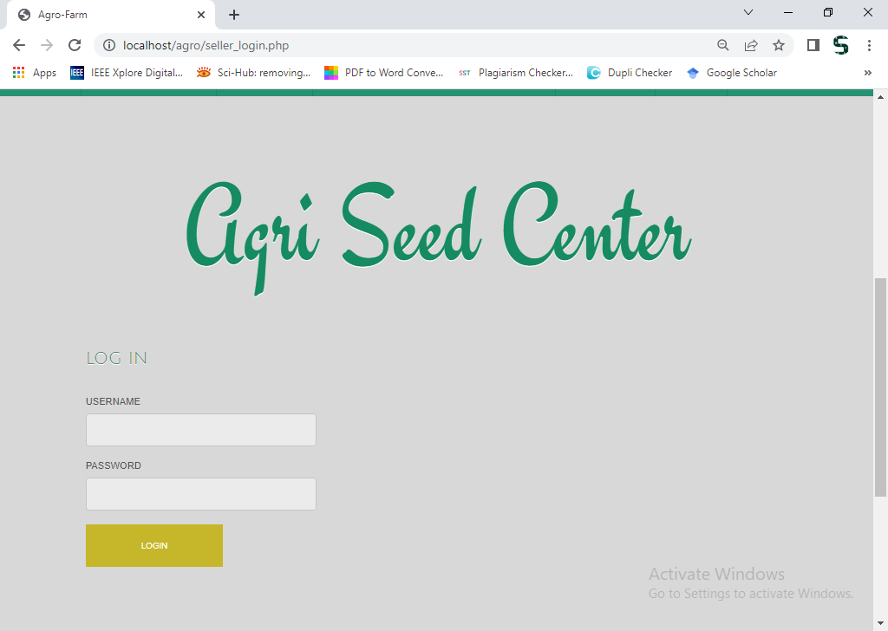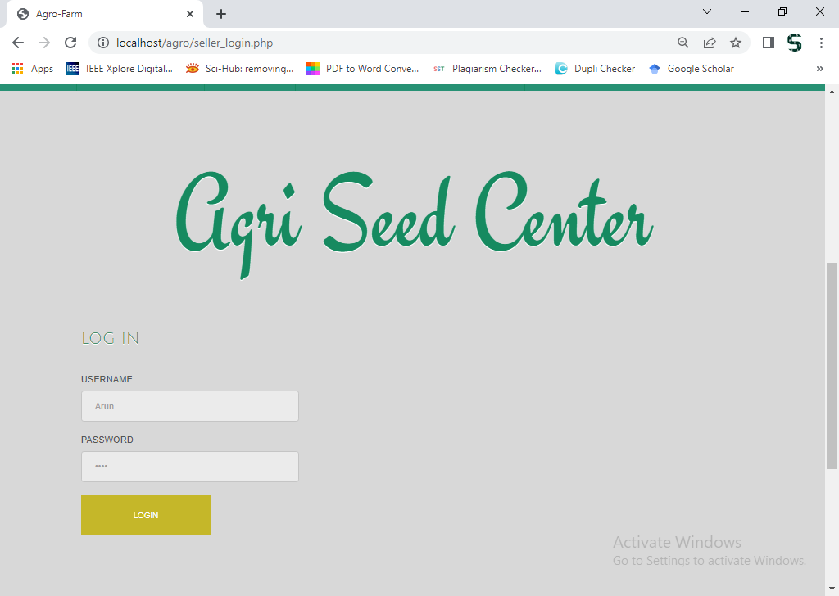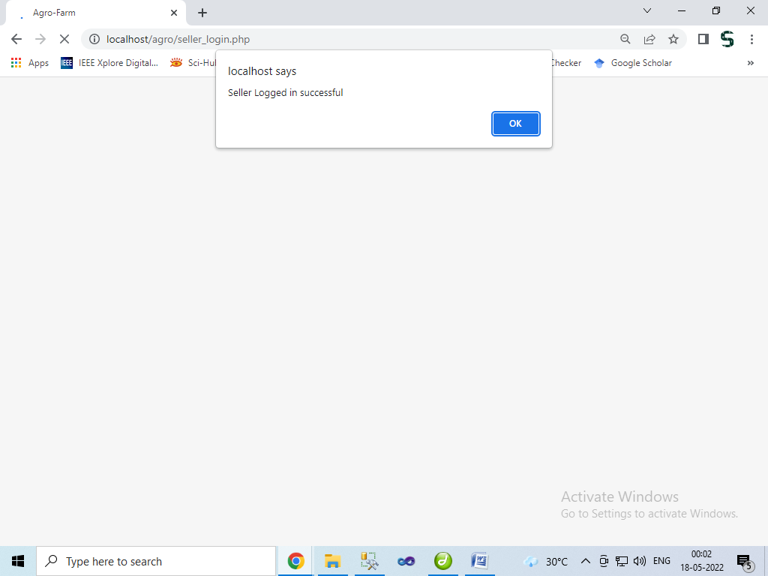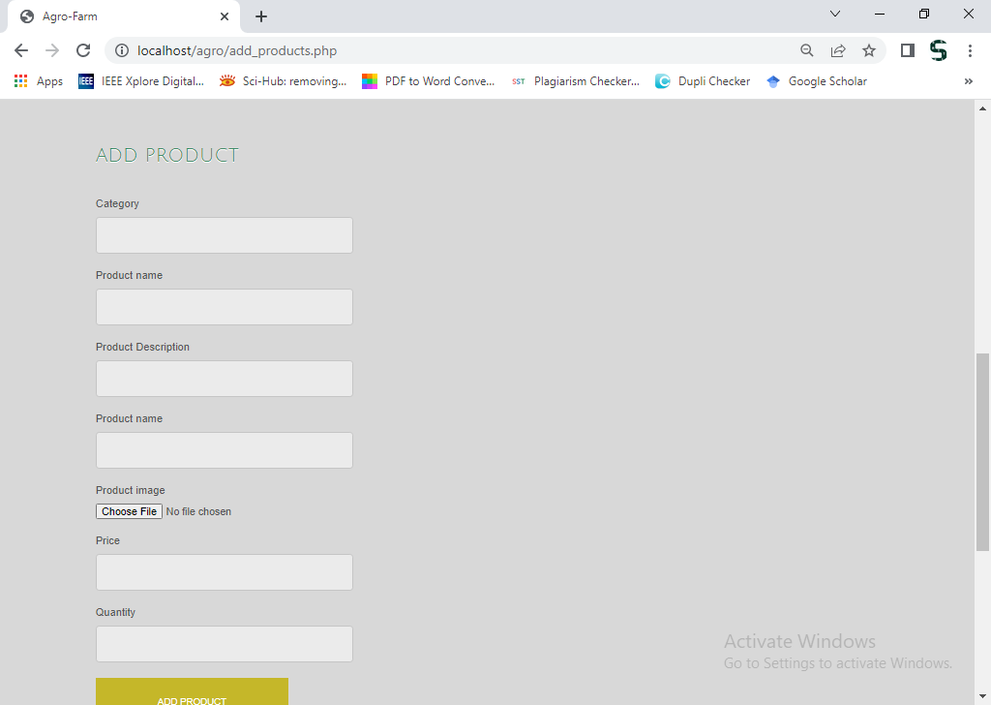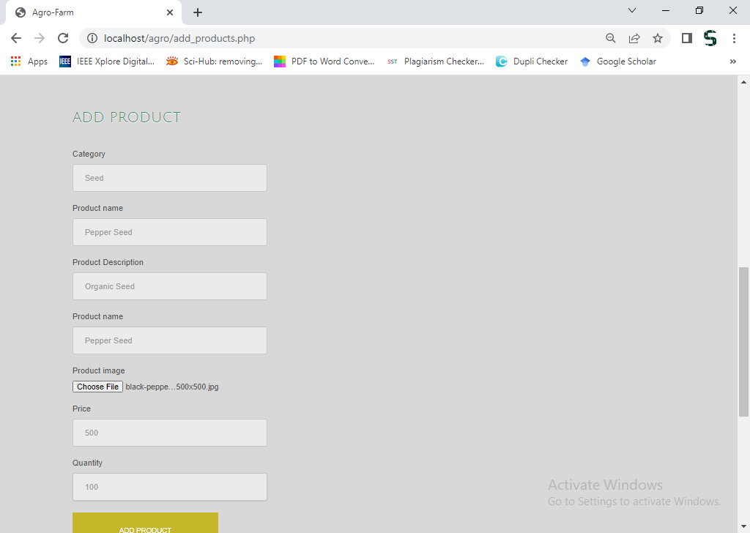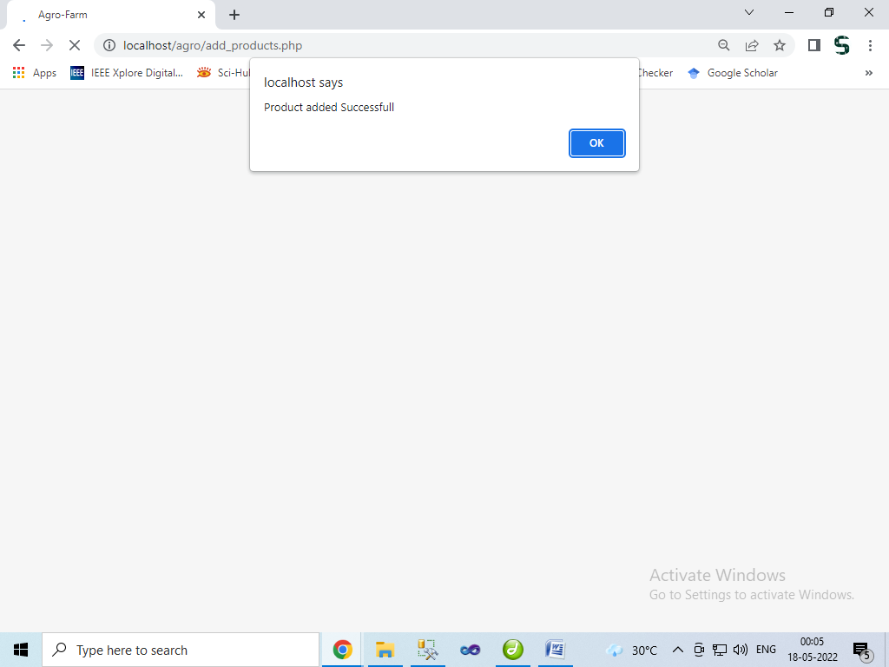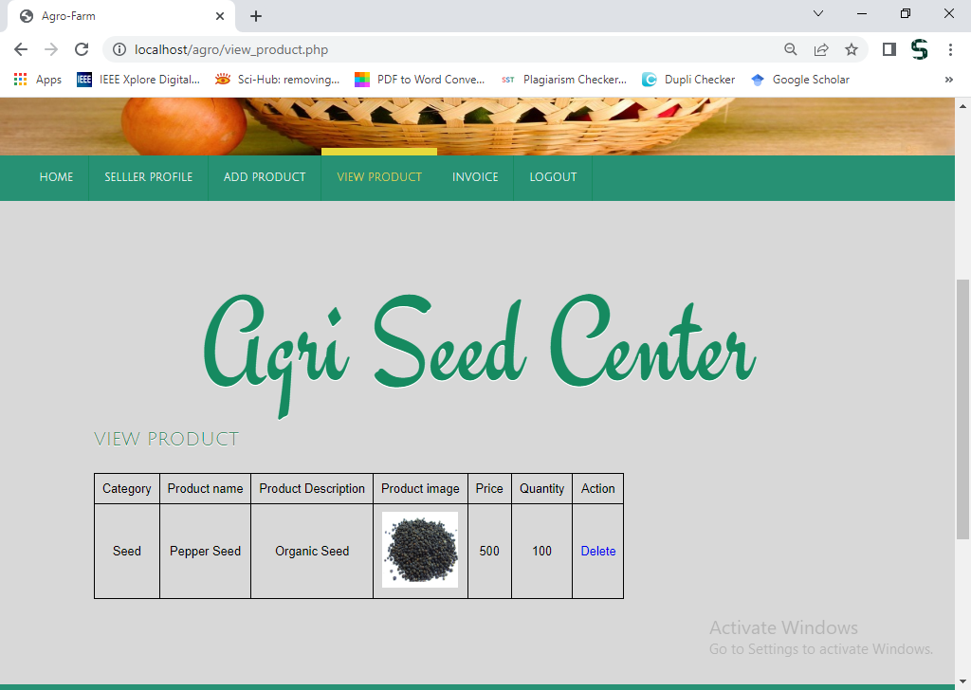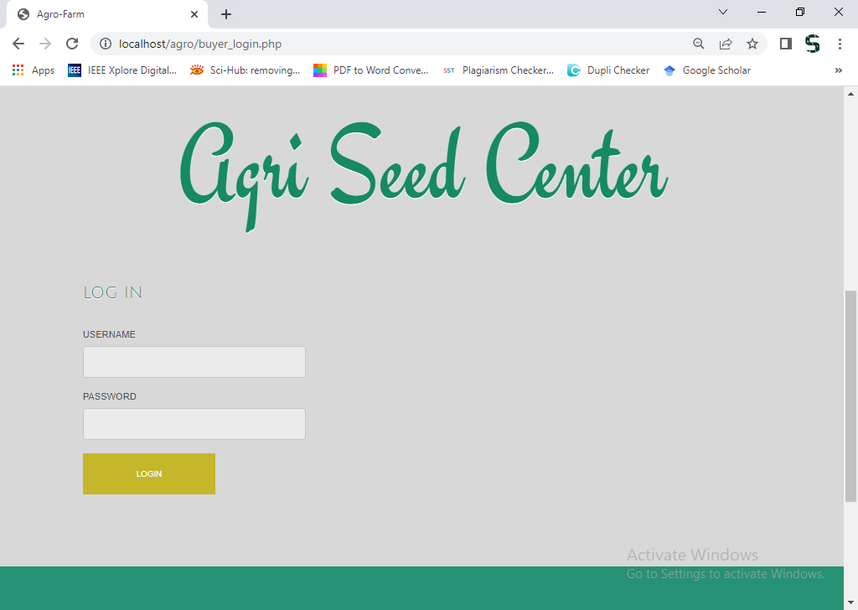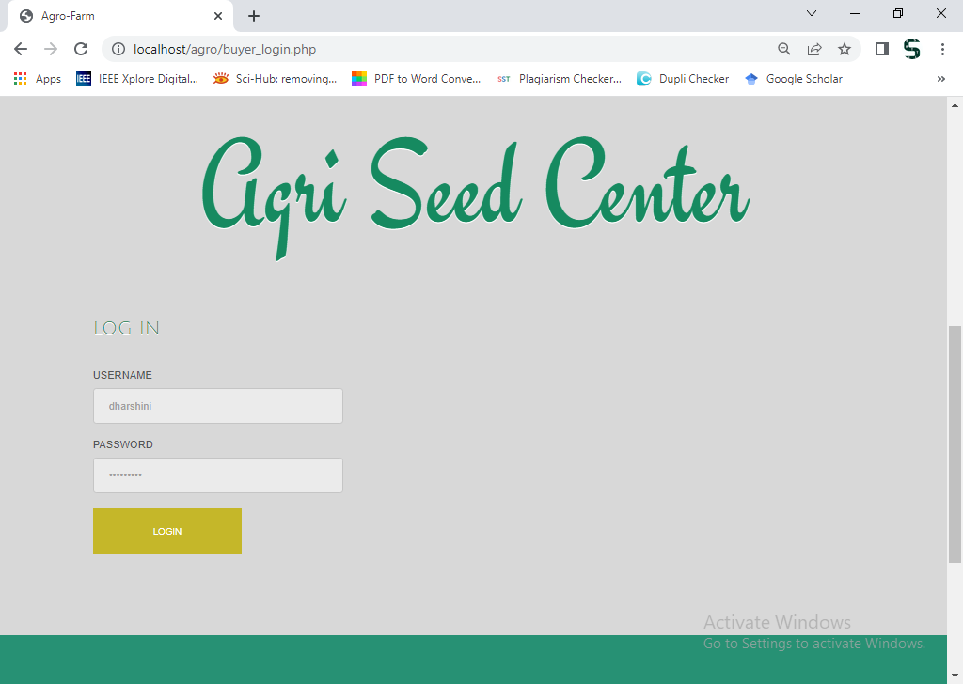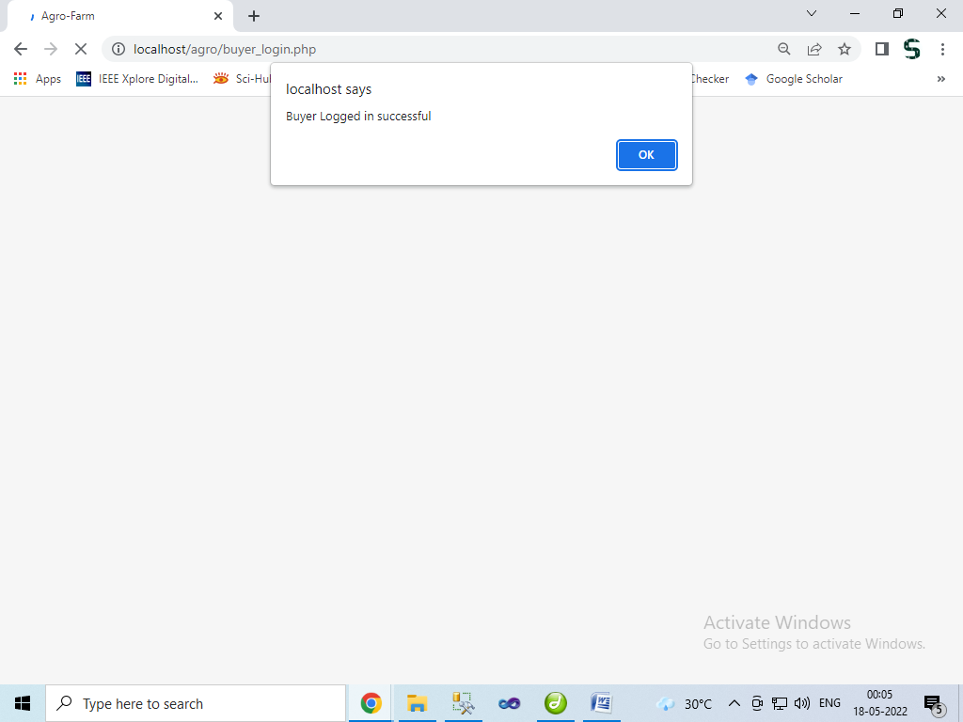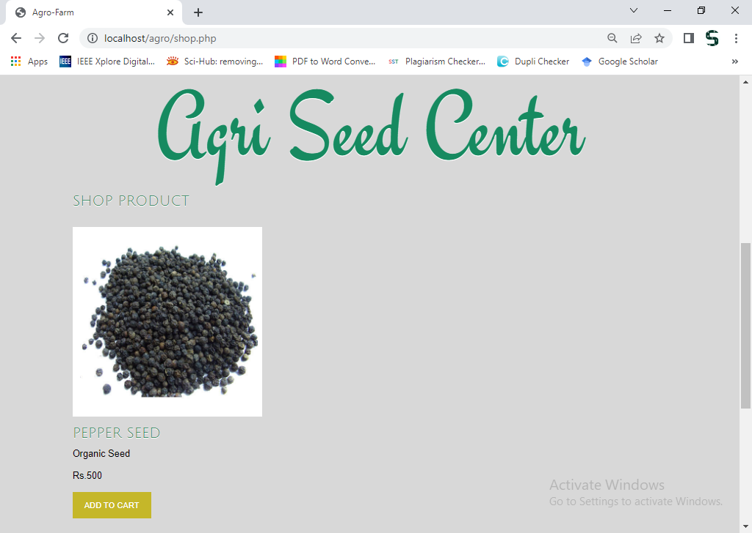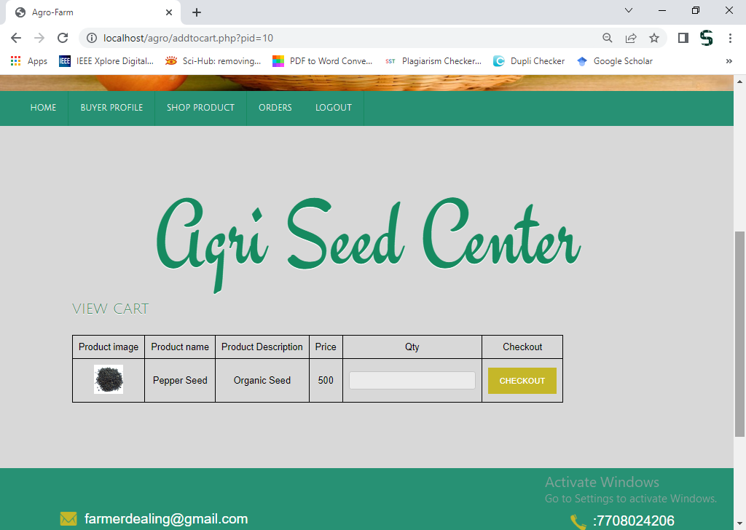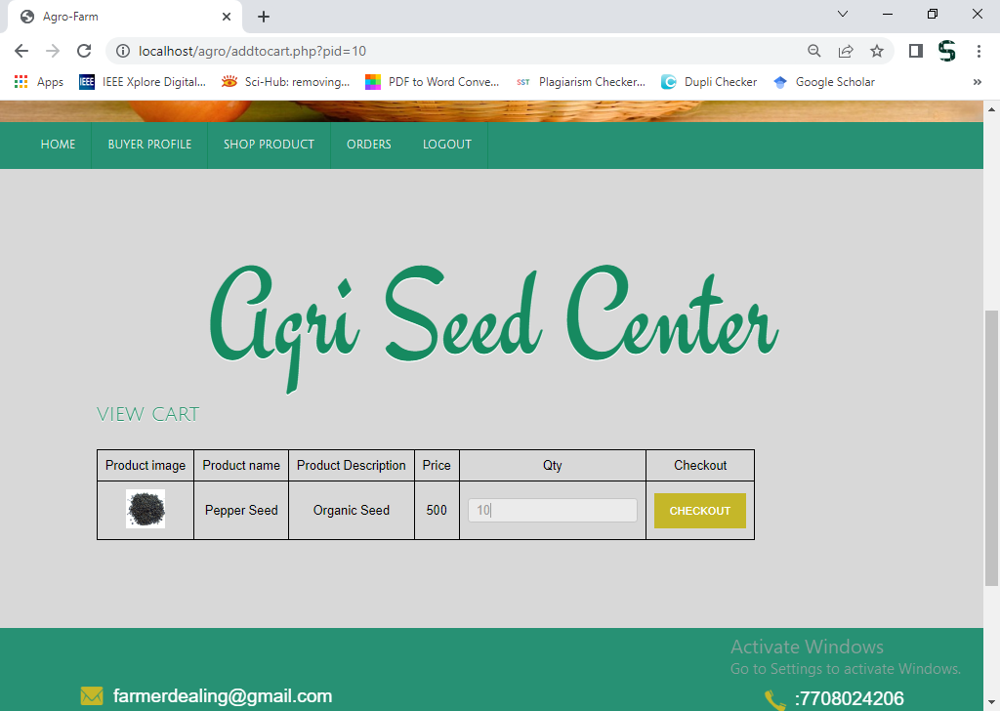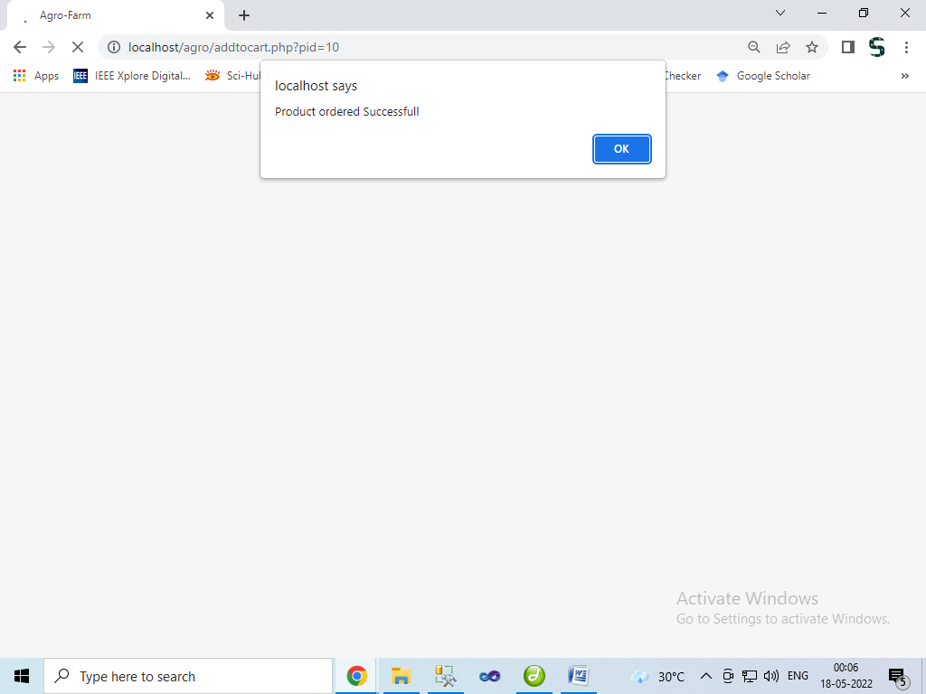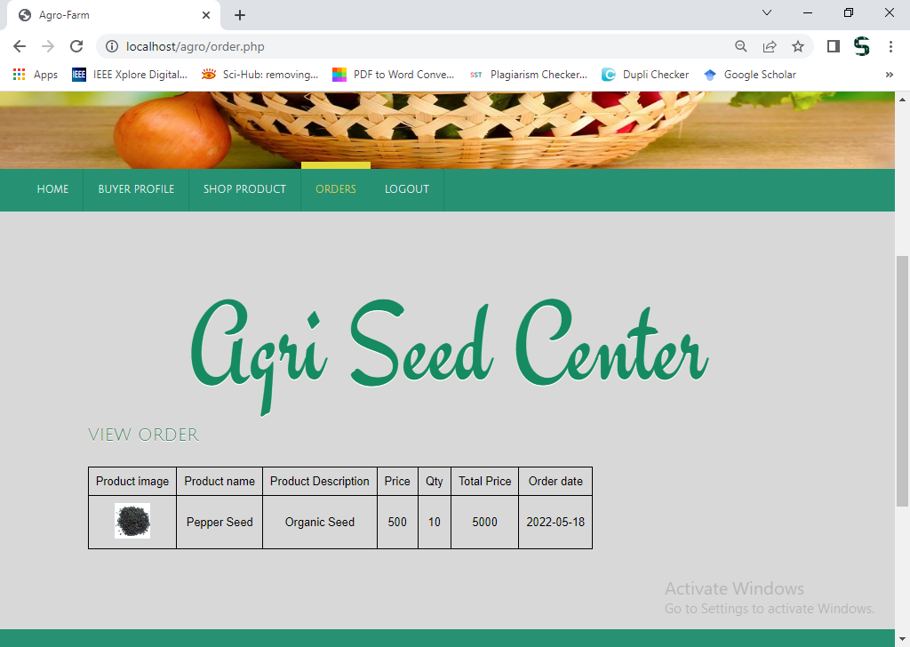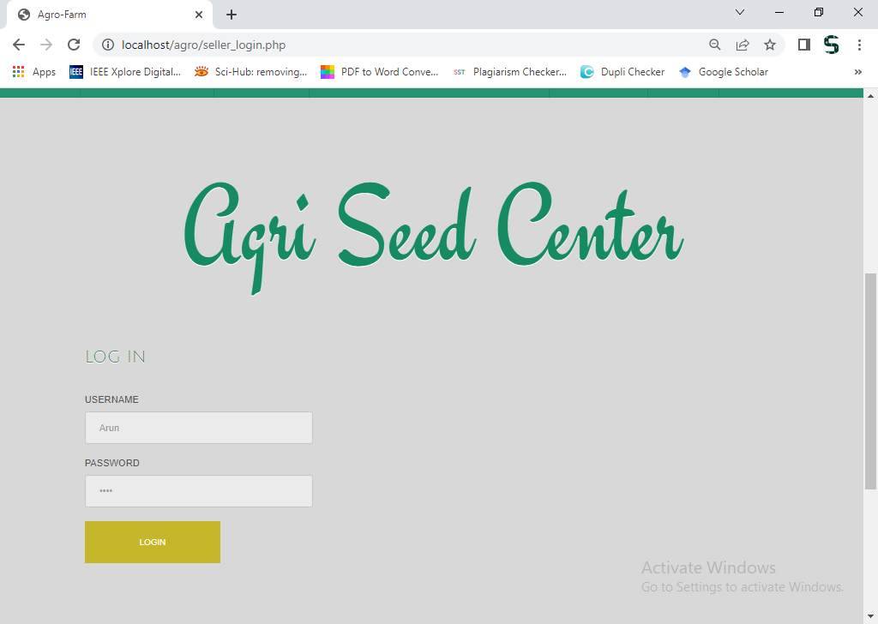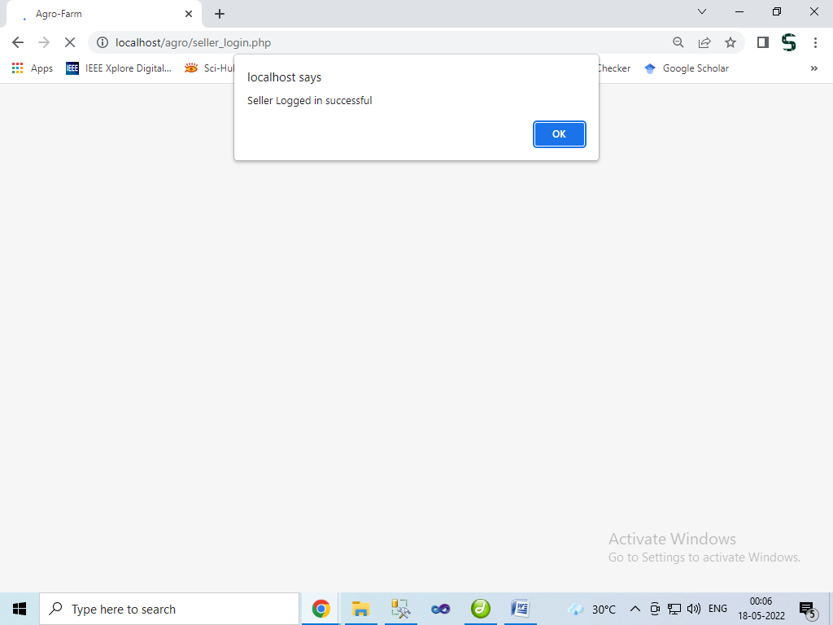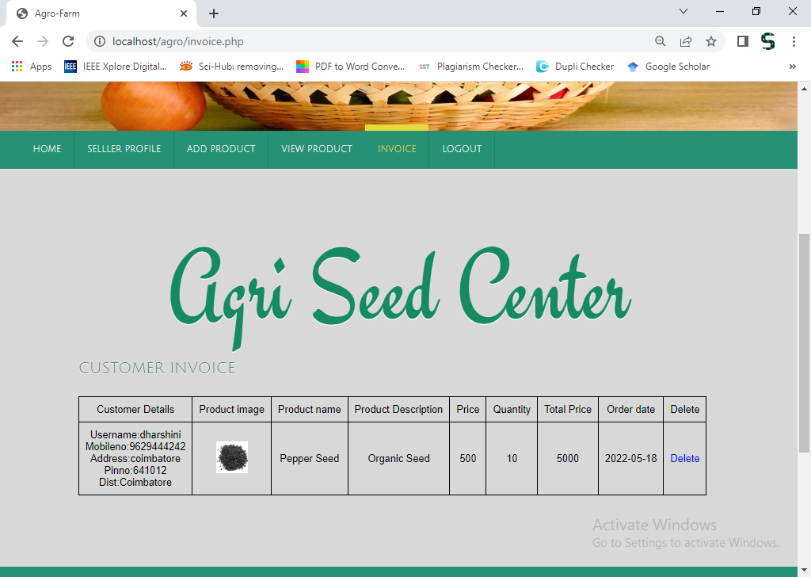
Sample coding
<?php
include "config.php";
include "header.php";
?>
<div class="wrap">
<div class="wrapper">
<div class="main">
<div class="content">
<a href="index.php"><h2>Agri Seed Center</h2></a>
</div>

<div class="ser-main">

<div class="ser-grid-list img_style">
<h3 class="style"><a href="">Add Product</a></h3>

<div class="contact-form">

<form method="POST" action="" name="add_product" enctype="multipart/form-data">
<div>
<span><label>Category</label></span>
<span><input name="cat" type="text" class="textbox"></span>
</div>
<div>
<span><label>Product name</label></span>
<span><input name="pname" type="text" class="textbox"></span>
</div>

<div>
<span><label>Product Description</label></span>
<span><input name="pdescp" type="text" class="textbox"></span>
</div>

<div>
<span><label>Product name</label></span>
<span><input name="pname" type="text" class="textbox"></span>
</div>

<div>
<span><label>Product image</label></span>
<span><input name="pimg" type="file" class="textbox"></span>
</div>
<div>
<span><label>Price</label></span>
<span><input name="price" type="text" class="textbox"></span>
</div>

<div>
<span><label>Quantity</label></span>
<span><input name="qty" type="text" class="textbox"></span>
</div>

<div>
<span><input type="submit" value="Add Product" name="submit" ></span>
</div>

</form>

</div>

</div>

<div class="clear"></div>
</div>
</div>
<div class="clear"></div>
</div>
</div>
<?php
if(isset($_POST['submit']))
{
$pimage=$_FILES['pimg']['name'];
$pname=mysql_real_escape_string($_POST['pname']);
$cat=$_POST['cat'];
$pdescp=mysql_real_escape_string($_POST['pdescp']);
$price=$_POST['price'];
$qty=$_POST['qty'];
$sid=$_SESSION['sid'];
mysql_query("insert into product(pname,pdescp,cat,price,qty,pimage,sid)values('$pname','$pdescp','$cat','$price','$qty','$pimage','$sid')")or die(mysql_error());
move_uploaded_file($_FILES['pimg']['tmp_name'],"upload/$pimage");
echo "<script type='text/javascript'>alert('Product added Successfull');</script>";
echo '<meta http-equiv="refresh" content="0;url=add_products.php">';
}
include "footer.php";
?>

<?php
include "config.php";
include "header.php";
?>
<div class="wrap">
<div class="wrapper">
<div class="main">
<div class="content">
<a href="index.php"><h2>Agri Seed Center</h2></a>
</div>
<h3 class="style"><a href="">View Cart</a></h3>
<div class="specials-grids">

<form action="" method="post">
<?php
$pid=$_GET['pid'];
$t=mysql_query("select * from product where pid=$pid");
while($w=mysql_fetch_array($t))
{
$pimage=$w['pimage'];
$pname=$w['pname'];
$pdescp=$w['pdescp'];
$price=$w['price'];
$qty=$w['qty'];
?>
<table align="left" cellpadding="10" cellspacing="0" border="1" class="cart_table">
<tr><td>Product image</td><td>Product name</td><td>Product Description</td><td>Price</td><td>Qty</td><td>Checkout</td></tr>
<?php
echo "<tr><td><img src='upload/$pimage' height='50px' /></td><td>$pname</td><td>$pdescp</td><td>$price</td><td><input type='text' name='qty' class='cart_box' ></td><td><input type='submit' name='checkout' value='Checkout' class='add_cart'></td></tr>";
?>
</table>
</form>
<?php
}
?>

<div class="clear"> </div>
</div>

<div class="clear"></div>

</div>
<div class="clear"></div>
</div>
</div>
<?php
if(isset($_POST['checkout']))
{
$stid=$_SESSION['bid'];
$pid=$_GET['pid'];
$qty=$_POST['qty'];
$date=date("Y-m-d");
mysql_query("insert into cart(stid,pid,qty,date)values('$stid','$pid','$qty','$date')")or die(mysql_error());

echo "<script type='text/javascript'>alert('Product ordered Successfull');</script>";
echo '<meta http-equiv="refresh" content="0;url=order.php">';
}
include "footer.php";
?>
<?php
include("config.php");
if(isset($_POST['submit']))
{

$username=mysql_real_escape_string($_POST['username']);
$password=mysql_real_escape_string($_POST['password']);
$date=mysql_real_escape_string($_POST['date']);
$mobileno=mysql_real_escape_string($_POST['mobileno']);
$address=mysql_real_escape_string($_POST['address']);
$pinno=mysql_real_escape_string($_POST['pinno']);
$dist=mysql_real_escape_string($_POST['dist']);
$productdetails=mysql_real_escape_string($_POST['productdetails']);

mysql_query("insert into reg1(id,username,password,date,mobileno,address,pinno,dist,productdetails)
values( NULL,'$username','$password','$date','$mobileno','$address','$pinno','$dist','$productdetails')");
echo "done";
}
if(isset($_POST['login']))
{

$username=mysql_real_escape_string($_POST['username']);
$password=mysql_real_escape_string($_POST['password']);
$login_qry="SELECT * FROM reg1 WHERE username='$username' and password='$password'";
$result=mysql_query($login_qry)or die("cant access");
$count=mysql_num_rows($result);
if($count>0){
header("location:buyer.php");
}
else{
$msg="username or password incorrect!";
}

}
?>

